# COSC 2307

# ASSIGNMENT 2 – PART 1

## Question 1a (2.5 points) Use HR database (Sample tables and data are in DatabaseHR.pdf file or you can download it from the course website). Write a query to show all the names of regions, names of countries and number of locations in them (including regions/countries with 0 locations). Sort by number of locations starting from the highest number.

# Q1 (a)

SELECT R.Region_Name, C.Country_Name, COUNT(L.Location_id) AS Number_of_Locations

FROM Region AS R

LEFT JOIN Countries AS C ON R.Region_ID = C.Region_ID

LEFT JOIN Locations AS L ON C.Country_ID = L.Country_ID

GROUP BY R.Region_Name, C.Country_Name

ORDER BY Number_of_Locations DESC;

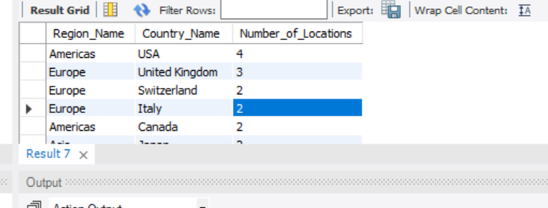

# Question 1b (2.5 points) Use HR database (Sample tables and data are in DatabaseHR.pdf file). Write a query to show all the employees who have salary between 1000 and 2000. Display: last name, first name, employee_id, department name, job title, salary. Sort the output by last name and first name.

# Q1 (b)

select E.LAST_NAME, E.FIRST_NAME, E.EMPLOYEE_ID, D.DEPARTMENT_NAME, J.JOB_TITLE, E.SALARY

from Employee E

join Departments D ON E.DEPARTMENT_ID = D.DEPARTMENT_ID

join Jobs J ON E.JOB_ID = J.JOB_ID

where E.SALARY between 1000 AND 2000

order by E.LAST_NAME, E.FIRST_NAME;

Minimum salary in sample data is 4200. That’s why no output.

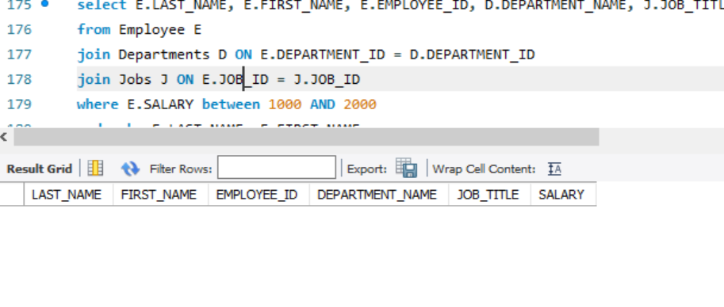

# ASSIGNMENT 2- PART 2:

# Question 2a (2.5 points) Use HR database (Sample tables and data are in DatabaseHR.pdf file). Write a query that shows: department name, the number of employees in each department (include departments with 0 employees), min, max, and average salary for all the departments in the database. Then use UNION ALL to append at the end text: Totals and the total number of employees, average, min, and max salary for the entire company.

# Q2 (a)

SELECT D.DEPARTMENT_NAME,

COUNT(E.EMPLOYEE_ID) AS Number_of_Employees,

MIN(E.SALARY) AS Min_Salary,

MAX(E.SALARY) AS Max_Salary,

AVG(E.SALARY) AS Average_Salary

FROM Departments D

LEFT JOIN Employee E ON D.DEPARTMENT_ID = E.DEPARTMENT_ID

GROUP BY D.DEPARTMENT_NAME

UNION ALL

-- Query to retrieve totals for the entire company

SELECT 'Totals' AS DEPARTMENT_NAME,

COUNT(E.EMPLOYEE_ID) AS Number_of_Employees,

MIN(E.SALARY) AS Min_Salary,

MAX(E.SALARY) AS Max_Salary,

AVG(E.SALARY) AS Average_Salary

FROM Employee E;

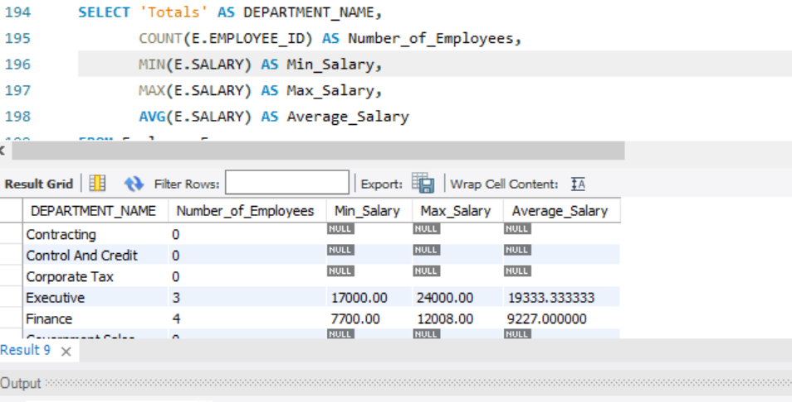

# Question 2b (2.5 points) Use HR database (Sample tables and data are in DatabaseHR.pdf file). Write a query to show employee id, last name, first name of all the employees, their managers, and the managers of their managers.

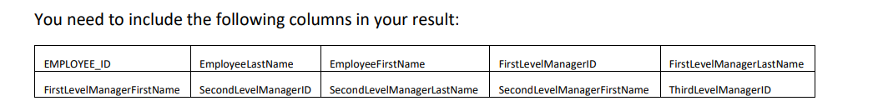

# Q2 (b)

SELECT E1.EMPLOYEE_ID AS EMPLOYEE_ID, E1.LAST_NAME AS EmployeeLastName, E1.FIRST_NAME AS EmployeeFirstName,

E2.EMPLOYEE_ID AS FirstLevelManagerID,E2.LAST_NAME AS FirstLevelManagerLastName, E2.FIRST_NAME AS FirstLevelManagerFirstName,

E3.EMPLOYEE_ID AS SecondLevelManagerID, E3.LAST_NAME AS SecondLevelManagerLastName, E3.FIRST_NAME AS SecondLevelManagerFirstName,

E4.EMPLOYEE_ID AS ThirdLevelManagerID,E4.LAST_NAME AS ThirdLevelManagerLastName, E4.FIRST_NAME AS ThirdLevelManagerFirstName

FROM Employee E1

LEFT JOIN Employee E2 ON E1.MANAGER_ID = E2.EMPLOYEE_ID

LEFT JOIN Employee E3 ON E2.MANAGER_ID = E3.EMPLOYEE_ID

LEFT JOIN Employee E4 ON E3.MANAGER_ID = E4.EMPLOYEE_ID;

